Flask Hiring Test

Name : Logunathan J

Reg. No. : 721220106048

Phone No. : 9787841934

In this project we should be able to add new items, and make new purchase and make new sales and see its running cash balance and we can download a history.

Prerequisites are,

Python, Pip, Flask

Login Page:

Press F11 for enable full screen mode.

In this page, if we have user name and password then you will login. Otherwise click Register to create an account.

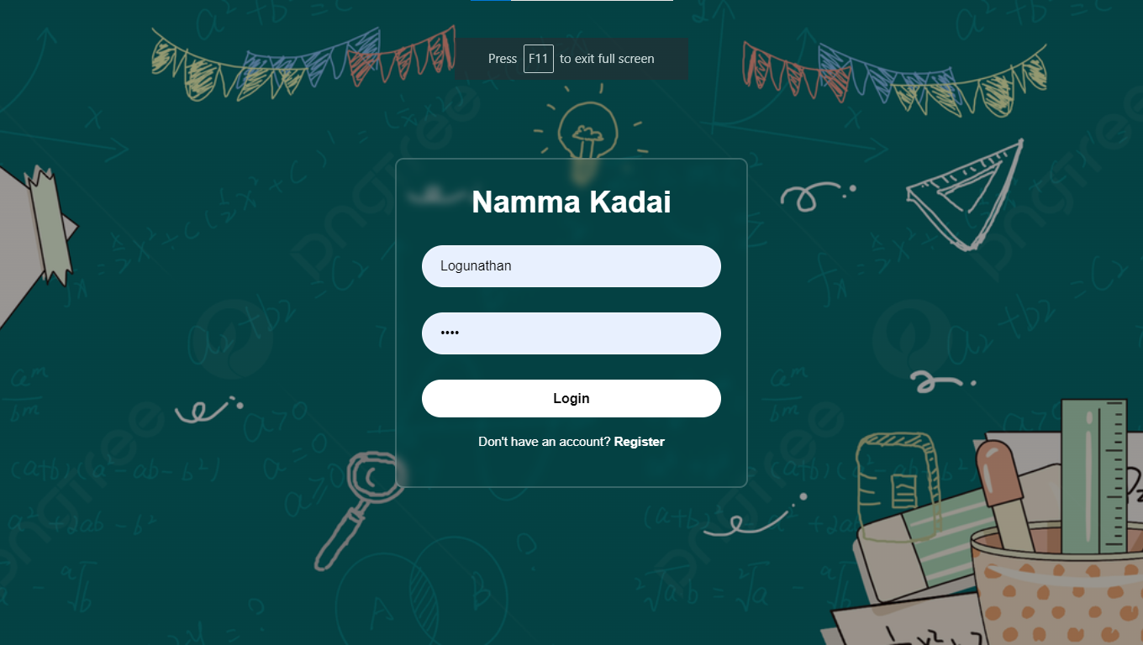

Registration page:

Give Username and Password.

Backend validation for password and confirm password

So, Enter both are same.

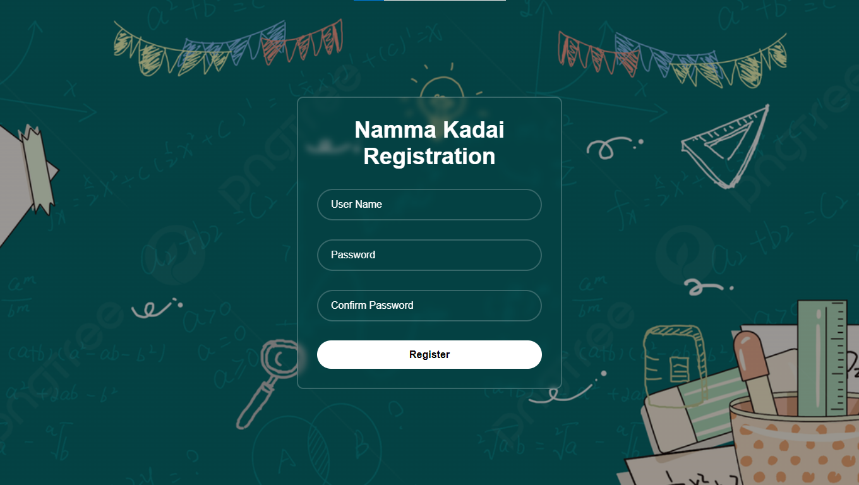

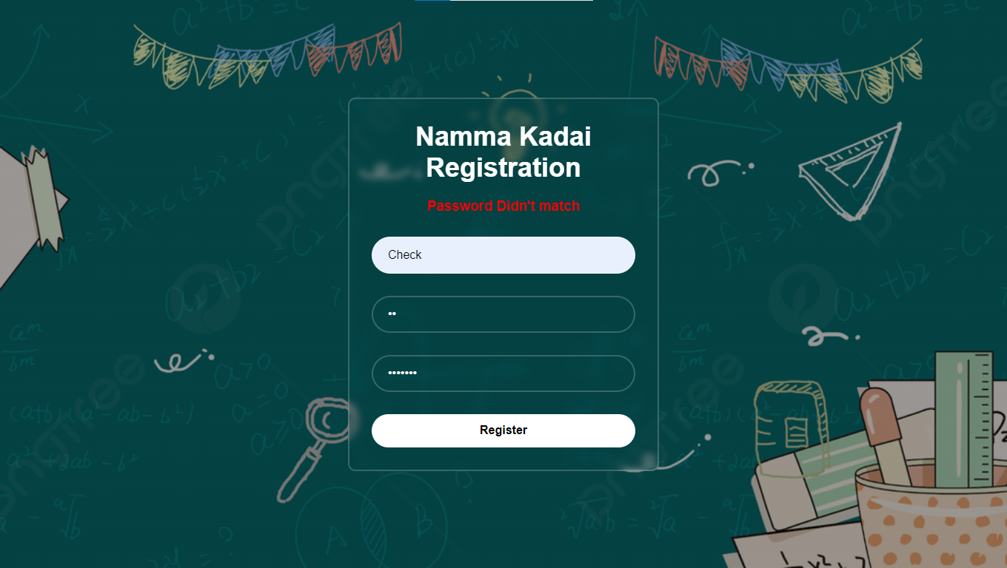

After Success the login process then it redirect to the home page.

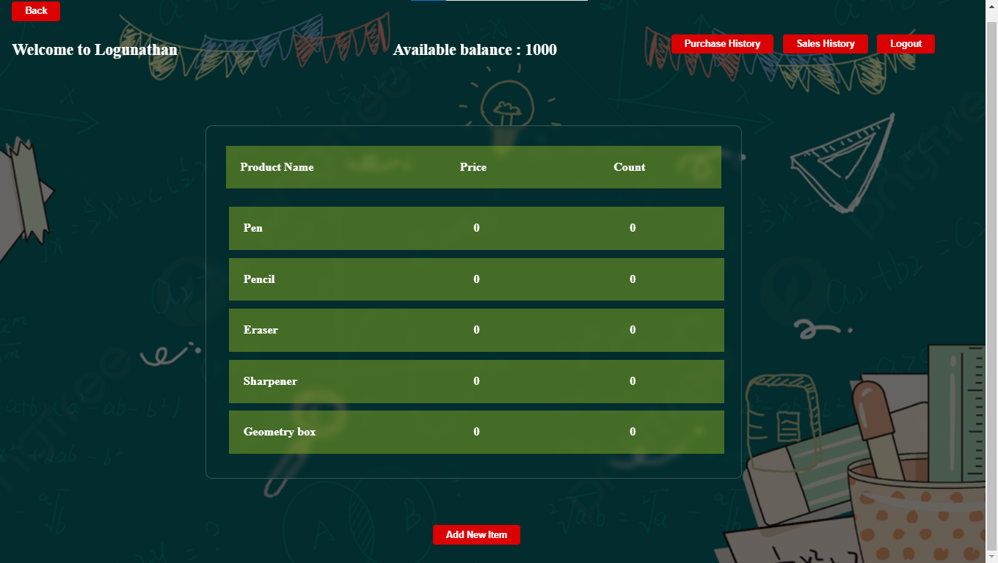

In this page we can add new Item by clicking the Add new Item Button.

If we want to purchase or sell or change the name of the product by clicking the label row.

If we change a name by giving an input to the input box and click save button for save the name.

If we purchase particular item then click purchase button.

If we sell the particular item then click selling button.

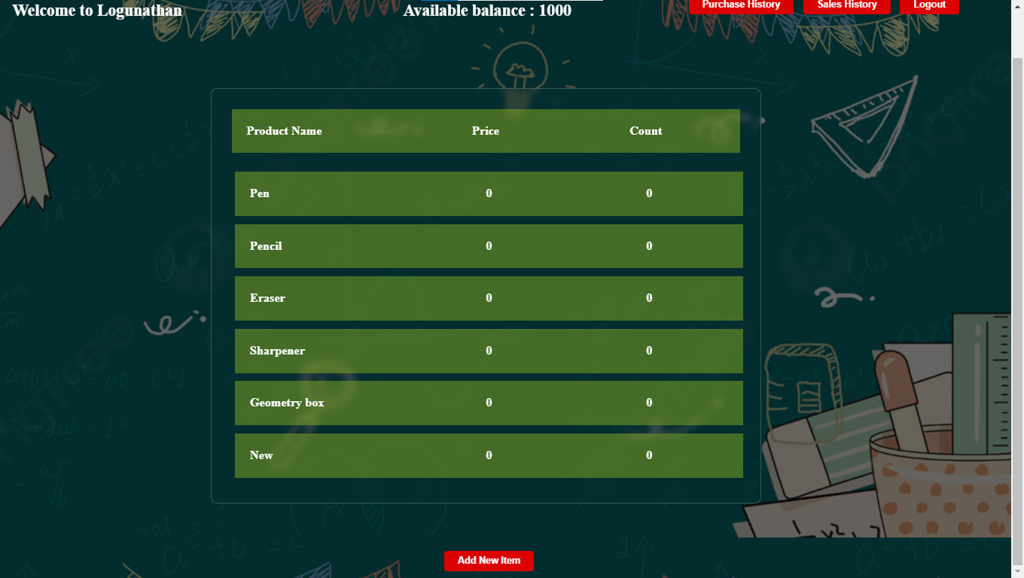



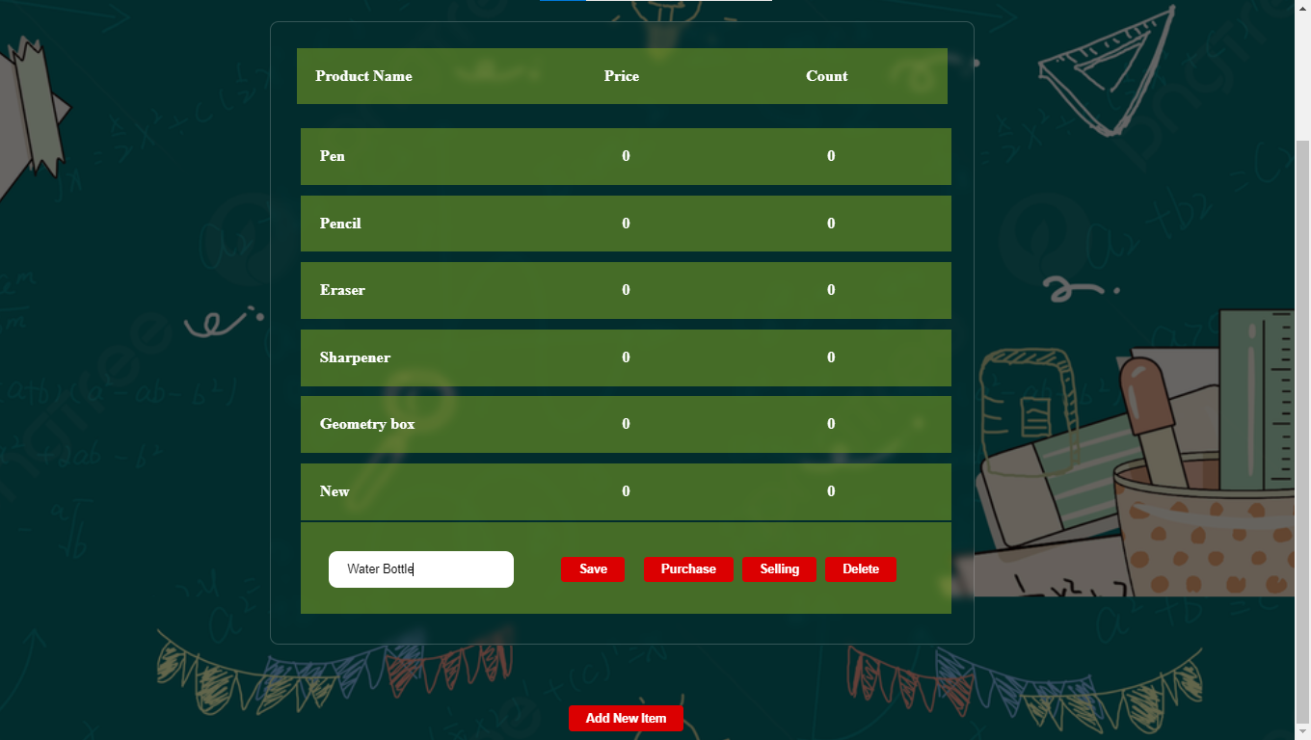

Press save button to change a name

Give input to the box

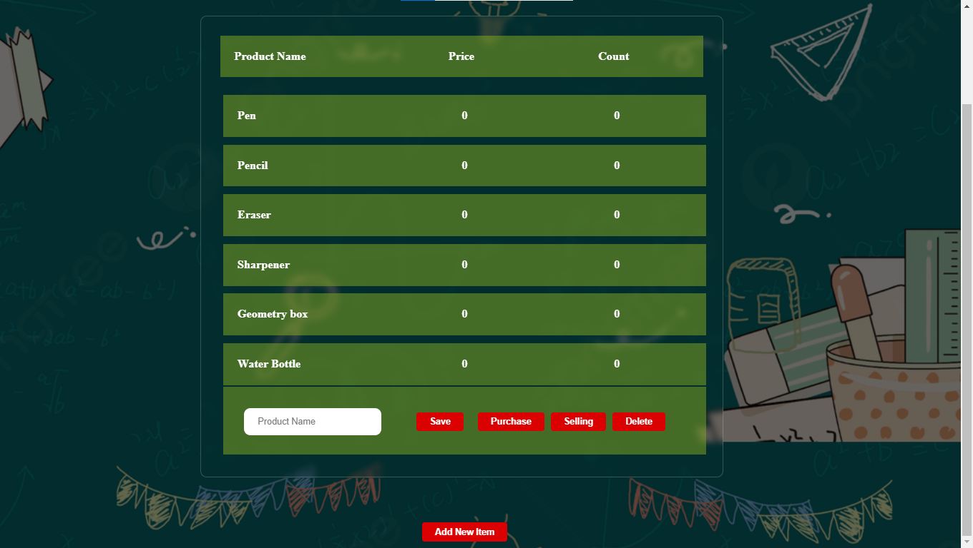

By clicking purchase button we can buy a new item

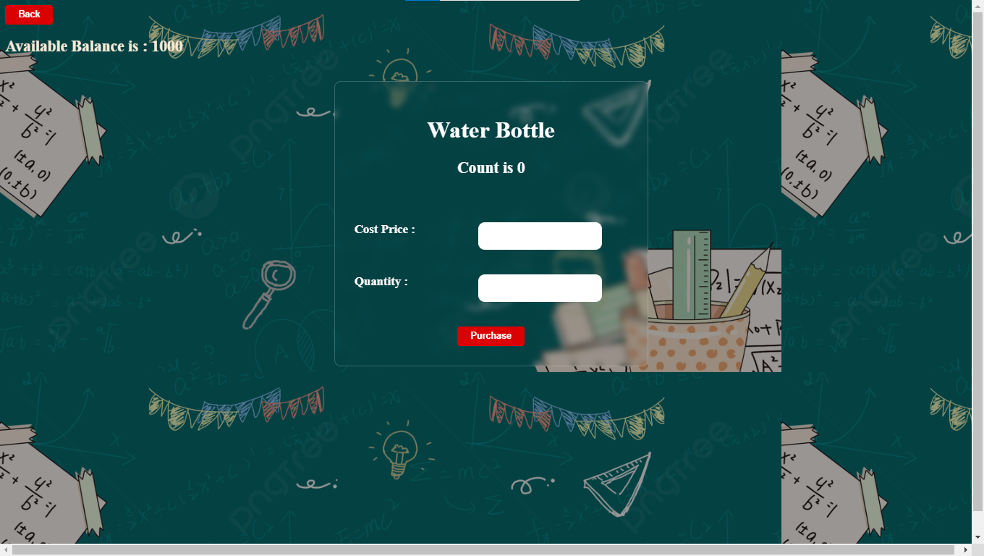

Give Cost price and Quantity then press purchase button.

It will be check in backend weather the given process is correct or not.

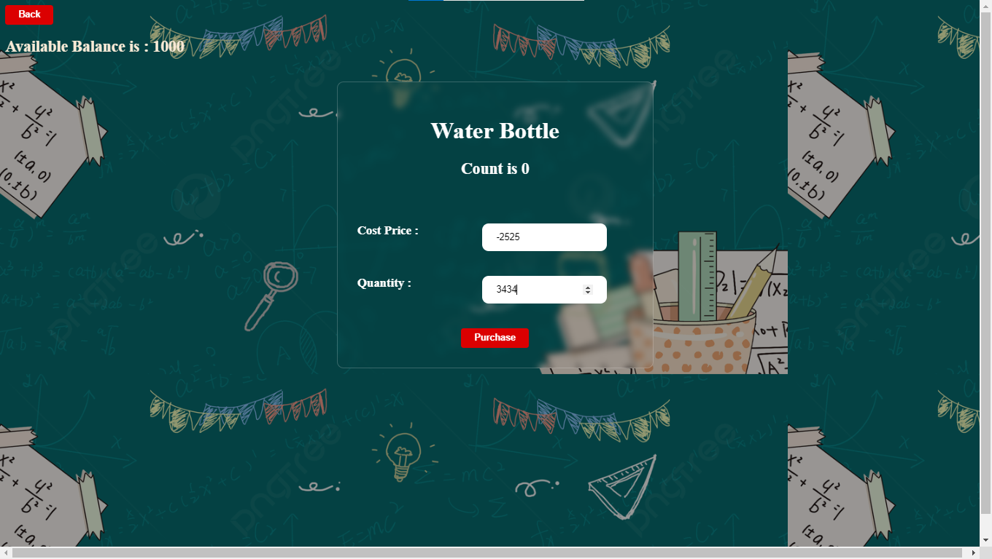

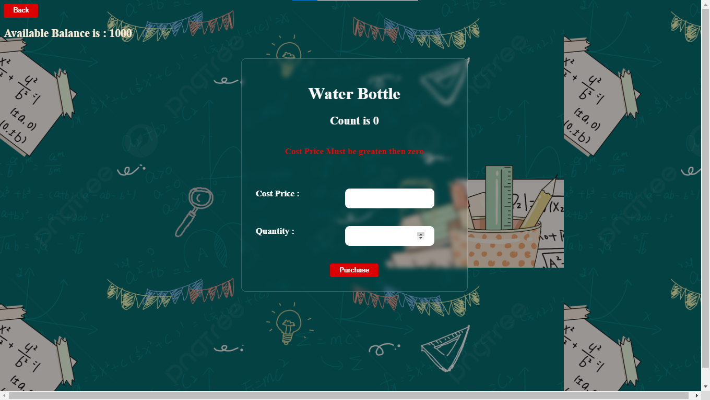

If we give a proper value then it will change the

Available amount and Product count.

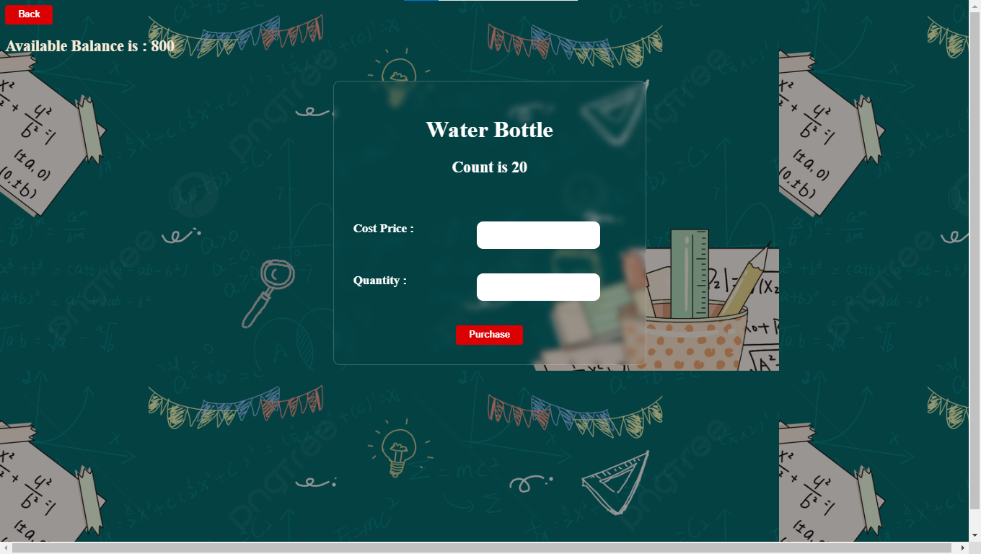

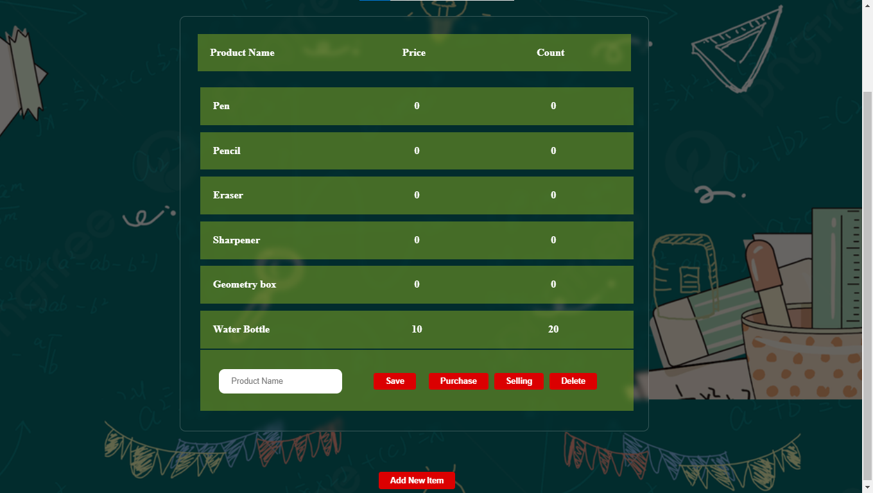

By pressing delete button we can remove the Item.

By clicking sell button we can sell a product. It is like a same process of purchase and validation also added.

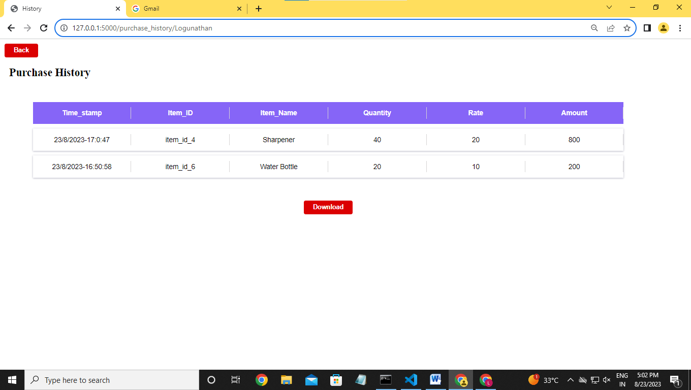

When we click a purchase history button it will show the purchase history.

When we click a sales history button it will show the sales history.

By pressing download we can download a CSV file for analysis.